**P273/1**

**GEOGRAPHY OF**

**EAST AFRICA**

**Paper 1**

**2:30 HOURS**

**ST JOHN’S HIGH SCHOOL KAWEMPE**

***Uganda Certificate for Lower Secondary Education {UCLSE}***

**S.1– GEOGRAPHY PAPER 1**

**TIME: 2:30 HOURS**

**PART: I**

**MAP WORK PHOTOGRAPHIC INTERPRETATION, FIELD WORK**.

Answer FOUR questions from part II including question 1, 2 and 3 which are compulsory.

**SECTION: A**

**COMPULSORY QUESTION: MAPWORK (25 MARKS**)

Study the East Africa ***1:50,000*(UGANDA**) **LUKAYA** map extract part of sheet **79/2** series **Y732 2-USD** edition and answer questions that follow.

(a) (i) State the grid reference of the Antiquity at Lukaya. (01 mark)

(ii) Name the man made feature found at grid reference 697957 (01 mark)

(b) (i) State the bearing of a church at Kankobe (878938) from the borehole at 736916 (03 marks)

(ii) Identify the Hemisphere in which Lukaya is found. (02 marks)

(iii) Identify the Location of Lukaya . (02 marks)

(c) Draw a sketch map of the portion between Northing 88 and 98, and Easting 80 and 88 and on it mark

and name; (10 marks)

(i) contour 3800

(ii) the seasonal swamp

(iii) lake victoria

(iv) Linear Settlement.

(d) (i) Describe the relief of the Area shown on the map. (03 marks)

(ii)Identify any three economic activities taking place in the area.(03 marks)

2. **COMPULSORY PHOTOGRAPHIC INTERPRETATIONS. (20 marks)**

**Answer all parts of the Question.**

***Study the photograph provided below and answer the questions that follow.***

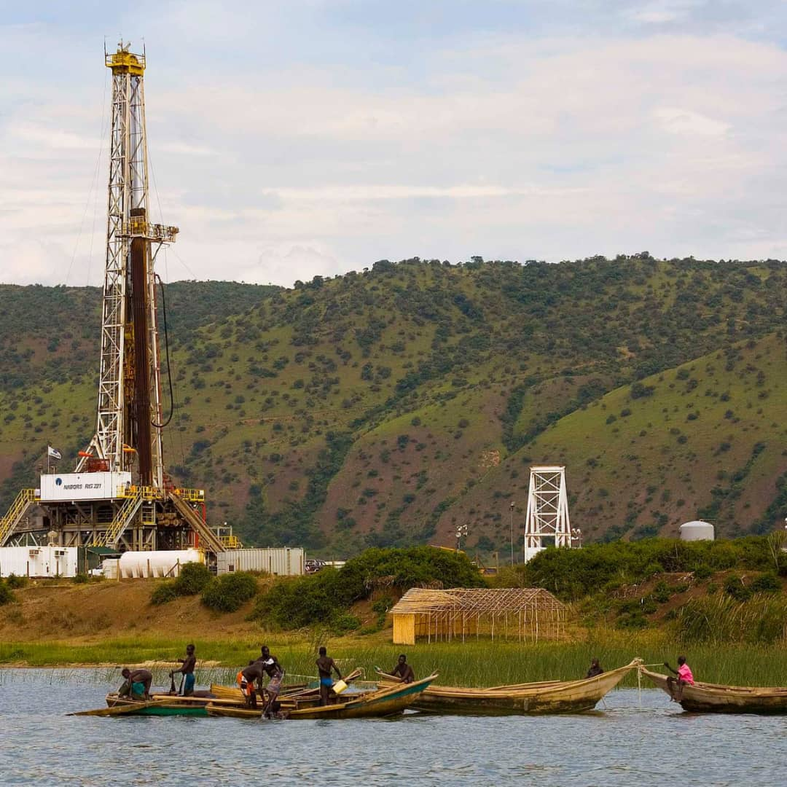

1. Identify the type of photograph shown above (02 mark)
2. Identify the economic activities in the
3. Left middle ground
4. Fore ground (04mks)
5. Describe the factors which have favoured the economic activity in the left middle ground. (07marks)
6. Giving evidence from the photograph, explain the problems facing the people living around as shown in the photograph (05 marks)
7. Giving reasons for your answer, suggest **one** area in East Africa where the photograph could have been taken (02 marks)

**COMPULSORY FIELDWORK (20 MARKS)**

**For any one field work you have conducted**

3(a) (i) State the topic of the field work study. (02 marks)

(ii) Outline the objectives of the field work study. (05 marks)

(b) Outline the preparations you conducted before the study. (03 marks)

c) Draw a sketch map of the area studied during the field work and on it mark and label

(i) Physical features

(ii) Man-made features (07 marks)

(e) Explain how the fieldwork study enabled you to understand the geography of the area of study. (03marks)

**SECTION B ( ATTEMPT ONLY ONE QUESTION )**

1. In Africa, there is a section called East Africa. It consists of countries that vary in size and population. These countries include Uganda known as the pearl of Africa due to its beautiful features and culture she bears. The great Tanzania with one of the salty lakes like Lake Tanganyika, Kenya where one of the biggest port is located. East African countries as mentioned above they have the following population.

Uganda- 241,037

Tanzania- 945,087

Kenya – 580,367.

1. Using the knowledge got in this topic, draw a pie chart to show the population size of each country. (06 marks)
2. Identify the country with the:-
3. Largest population
4. Smallest population. (02 marks)
5. Draw a sketch map of East Africa and locate the countries named above, lakes like kyoga, Victoria, Malawi, turkana, Tanganyika and albert, different relief regions and at least two mountains. (12 marks)

5.(a) Draw a sketch map of East Africa and on it mark and name the following.

(i) Lakes: Magadi and George

(ii) Mountains: Rwenzori and Uluguru.

(iii) Rivers: Tana (08 marks)

(b)Describe the process that led to formation of Lake anganyika.(05marks)

(c)Explain the benefits of Lakes to the people of East Africa. (07 marks)

6. Study table 1; below showing the average annual fresh water fish catch in East Africa between 1993 and 1995 and answer the questions that follow

***Table 1:*** showing the average annual fresh water fish catch in East Africa between 1993 and 1995

|  |  |
| --- | --- |
| **Country** | **Annual fresh water fish catch (in tonnes)** |
| Kenya | 86,000 |
| Tanzania | 100,100 |
| Uganda | 117,600 |
| **Total** | **303,700** |

1. Draw a line graph to show the average annual fresh water fish catch in East Africa between 1993 and 1995 (05 marks)
2. (i) Name the country with the highest annual fresh water fish catch in East Africa (01 mark)

(ii) Describe the factors which have favoured fishing in the country named in (b) (i) above (05 marks)

1. Explain the problems faced by the fishing industry in East Africa (05 marks)
2. Outline the measures being taken to promote fishing in East Africa

(04 marks)